GMIT H Dip in Data Analytics
Computational Thinking with Algorithms Problem Sheet
Patrick Moore G00364753

Question 1
Consider the following method:
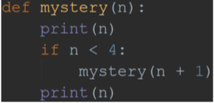

What will the output of the call mystery(1) be?
Write an explanation of the reasoning behind your answer, using the aid of either a recursion trace diagram or a stack diagram. Include any code which you write for testing or explanation purposes as part of your answer.
Answer for Question 1
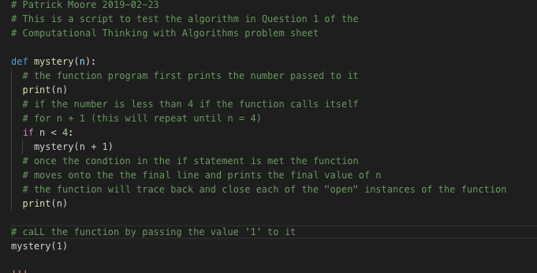
In order to test this, the method was coded in Python in Visual Studio code, and then called by passing the value ‘1’ to it.

The output of this function call is shown below:
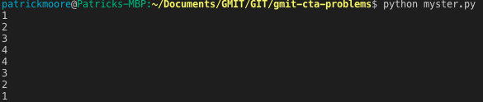
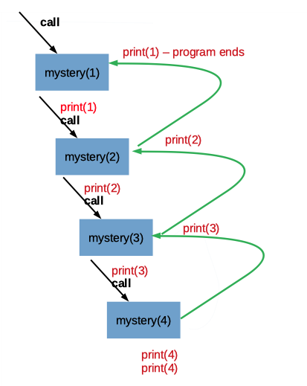
The recursion trace for the call “mystery(1)” is shown below with the original function.

- When the function is called with the original value for ‘n’ set to 1, the first thing the function does is print out this value (1 in this case)
- It then checks if the value passed for n is less than 4. If this is the case the function will recursively call itself for the case ‘n + 1’ (2 in this case). (Note that the recursion will continue until the base case of n is greater than or equal to 4 is met. Also note that the recursion is making progress towards the base case as on each subsequent call, the new value for n is closer to 4)
- The function with the value of set to ‘2’, first prints out ‘2’ and again checks to see if n is less than 4, it is so it calls the function again with n = 3.
- This third call of the function prints out ‘3’ and checks to see if n is less than 4. It is, so the it calls itself with n = 4.
- The 4th call of the function prints out ‘4’ and checks to see if n is less than 4. It isn’t, so the function moves down to the last line in the function and prints out ‘4’ again and finishes.
- Now, the third function call can move onto the final line in the function and print out its value for n (‘3’) and finish.
- Then, the second call of the function can move onto the final line in the function and print out it’s value for n (‘2’) and finish.
- Finally the initial call can move down to the last line in the function, printing it value for n (‘1’).
- The program terminates at this point

